Wheat Onboarding

# Agent Machine (Windows) Requirements:

1. Windows 7+
2. Install latest JDK (<http://www.oracle.com/technetwork/java/javase/downloads/jdk8-downloads-2133151.html>)
3. Install latest Android Studio (<https://developer.android.com/studio/index.html>)
4. Get Android SDK Path from Android Studio:
   1. Open Studio > Android Studio > File > Settings > Appearance & Behavior > System Settings > Android SDK > Android SDK Location
5. Get Java Home:
   1. Open cmd prompt and run *java -verbose* you will get the java home (e.g. *C:\Program Files\Java\jdk1.8.0_92*)
6. Set PATH environment variables; Go to Control Panel > System > Advanced System Settings > Environment variables > System Variables section > Path. Add following items in it:
   1. *{YOUR_ANDROID_SDK_PATH}/tools*
   2. *{YOUR_ANDROID_SDK_PATH}/platform-tools*
   3. *{YOUR_JAVA_HOME_PATH}/bin*
7. Set JAVA_HOME environment variable; Go to Control Panel > System > Advanced System Settings > Environment variables > System Variables section. Add following items in it:
   1. Add a new variable. Name it JAVA_HOME
   2. Update the value of this variable to *{YOUR_JAVA_HOME_PATH}*
8. Set ANDROID_HOME environment variable; Go to Control Panel > System > Advanced System Settings > Environment variables > System Variables section. Add following items in it:
   1. Add a new variable. Name it ANDROID_HOME
   2. Update the value of this variable to *{YOUR_ANDROID_SDK_PATH}*
9. Install Appium (<https://appium.io/downloads.html>)
10. Install Genymotion if you want to test on android emulators (<https://www.genymotion.com/>)
11. Install RedwoodHQ Agent on your Agent (Windows) machine (<http://redwoodhq.com/redwood-download/>) follow instructions from <http://www.manula.com/manuals/primatest/redwoodhq/2.0/en/topic/redwoodhq-agent>

# Agent Machine (Mac) Requirements:

1. Mac OS
2. Install latest JDK (<http://www.oracle.com/technetwork/java/javase/downloads/jdk8-downloads-2133151.html>)
3. Install latest Android Studio (<https://developer.android.com/studio/index.html>)
4. Install XCode 7.3.1 (<https://developer.apple.com/download/more/>)
5. Install Command Line Tool for Xcode 7.3.1 (<https://developer.apple.com/download/more/>)
6. Get Android SDK Path from Android Studio

Open Studio > Android Studio > Preferences > Appearence & Behaviour > System Settings > Android SDK (e.g. /Users/dinkark/Library/Android/sdk)

1. Get Java Home

Open terminal and run

|  |
| --- |
| /usr/libexec/java_home |

You will get the java home (e.g. /Library/Java/JavaVirtualMachines/jdk1.8.0_102.jdk/Contents/Home)

1. Set Environment variable

Open terminal and run following commands:

|  |
| --- |
| touch ~/.bash_profile  open -e ~/.bash_profile |

Paste these commands in .bash_profile file:

|  |
| --- |
| export PATH=${PATH}:{YOUR_ANDROID_SDK_PATH}/tools  export PATH=${PATH}:{YOUR_ANDROID_SDK_PATH}/platform-tools  export PATH=${PATH}:{YOUR_JAVA_HOME_PATH}/bin  export JAVA_HOME={YOUR_JAVA_HOME_PATH}  export ANDROID_HOME={YOUR_ANDROID_SDK_PATH} |

1. Save the file

Example *.bash_profile* file:

|  |
| --- |
| export PATH=${PATH}:/Users/dinkark/Library/Android/sdk/tools  export PATH=${PATH}:/Users/dinkark/Library/Android/sdk/platform-tools  export PATH=${PATH}:/Library/Java/JavaVirtualMachines/jdk1.8.0_102.jdk/Contents/Home/bin  export JAVA_HOME=/Library/Java/JavaVirtualMachines/jdk1.8.0_102.jdk/Contents/Home  export ANDROID_HOME=/Users/dinkark/Library/Android/sdk |

1. Install Appium (<https://www.npmjs.com/package/appium>)

|  |
| --- |
| npm install -g [appium@1.5.3](mailto:appium@1.5.3) |

1. Install Appium Doctor

|  |
| --- |
| npm install -g appium-doctor |

|  |
| --- |
| appium-doctor |

1. Run in terminal to check everything Appium need is fine.
2. Install Genymotion if want to test on android emulators (<https://www.genymotion.com/>)
3. Install RedwoodHQ Agent on your Agent (Mac) machine (<http://redwoodhq.com/redwood-download/>) follow instruction from <http://www.manula.com/manuals/primatest/redwoodhq/2.0/en/topic/redwoodhq-agent>

# Server Machine Requirements:

1. Windows OS
2. Install RedwoodHQ server on windows machine (<http://redwoodhq.com/redwood-download/>)
3. Download Wheat source from <https://github.com/Talentica/Wheat/tree/master/Project%20template>
4. Do the following on your RedwoodHQ server to get the Appium project template for scripts and actions on RedwoodHQ server  
   1. Copy *java_project_appium* folder and *java_project_appium.js* file from Wheat source folders into *C:\Program Files\RedwoodHQ\project_templates*.
   2. Open *C:\Program Files\RedwoodHQ\cli\createProject.js* and change

|  |
| --- |
| .usage('Usage: $0 --name [name] --template [Default, Java Based Selenium]') |

to

|  |
| --- |
| .usage('Usage: $0 --name [name] --template [Default, Java Based Selenium, Java Based Appium]') |

* 1. Open *C:\Program Files\RedwoodHQ\public\view\ProjectEdit.js*, Search "Project Template" and change

|  |
| --- |
| store: ["Default","Java Based Selenium"] |

to

|  |
| --- |
| store: ["Default","Java Based Selenium","Java Based Appium"] |

* 1. Open *C:\Program Files\RedwoodHQ\routes\scripts.js*, Search for CreateNewProject and add one if-else condition

|  |
| --- |
| if (template == "Java Based Selenium") {  template = "java_project_selenium";  }  else{  template = "java_project";  } |

to

|  |
| --- |
| if (template == "Java Based Selenium") {  template = "java_project_selenium";  }  else if (template == "Java Based Appium") {  template = "java_project_appium";  }  else{  template = "java_project";  } |

* 1. Now you will be able to create new project in RedwoodHQ with Appium using Create new project and start writing your test

# Before Running the Test

1. How to start Appium on a particular port:

|  |
| --- |
| appium -p 4496 -bp 2255 |

Run on your cmd prompt in Windows

or

|  |
| --- |
| appium -p 4492 |

on Mac OS. Here -

* 1. 4496, 4492 are the port on which we listen Appium http server response.
  2. 2255 is the port for Bootstrap port needed for Android only Used by Appium to talk to android device
  3. if you want multiple Appium session for parallel testing please make sure port for each session is different and bootstrap port should also be different for each android test session.
  4. The final url for listening will be something like this "<http://0.0.0.0:4492/wd/hub>" and "<http://0.0.0.0:4496/wd/hub>"

1. How to get UDID of device:

|  |
| --- |
| adb devices |

* Android: connect your device to your system and run on terminal you will get UDID for all the device connected
* IOS: connect your device to your system then open the XCode go to Windows-> Device-> select your device you will see the UDID in identifier field.

1. How to find Launcher Activity:
   1. Windows:
      1. Download Appium GUI (for mac or windows)
      2. Press on android settings
      3. Set in "App Path" path to apk
      4. Now in list "Package" see your apk package name
      5. In "Launch Activity" - first is 99% your first activity to start with. you can set it and try to start inspector by starting first Appium with Launch button and then hitting inspector Button. If it is not correct - then in logs will be said what activity is active instead you set in "Launch Activity"

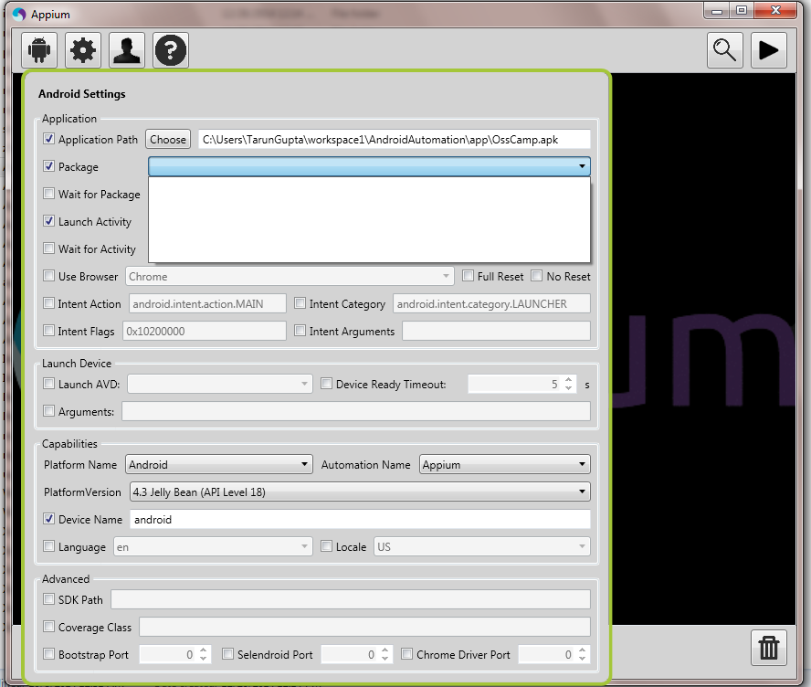

* 1. Mac:
     1. Open terminal and run following command

|  |
| --- |
| {AAPT_DIRECTORY}/aapt dump badging {APK_FULL_PATH} | grep launchable-activity:\ name |

* + 1. Example:

|  |
| --- |
| /Users/dinkark/Library/Android/sdk/build-tools/24.0.3/aapt dump badging  /Users/dinkark/Documents/AppiumTest/app/Android/Whatsapp.apk | grep launchable-activity:\ name |

1. To Run a test case, you must make sure the following things are running
   * RedwoodHQ agent (<http://www.manula.com/manuals/primatest/redwoodhq/2.0/en/topic/redwoodhq-agent>)
   * Appium on desired port
   * Device is connected or emulators are running